**AUTOMATIC WATER LEVEL CONTROLLER**

**Introduction**

Electronic water level indicators are available but they usually come with hefty price tag and are usually difficult to install. Most of the available systems use dipped electrodes of float switches which can be headache in the long run. The project we have chosen is based on contactless method as we do not want to affect the quality of water in the tank. Optical methods can be accurate but the sensors get dirty over time. Radar methods use high RF signals which are not suitable for DIY. On the other hand, ultrasonic sensors send ultrasonic waves instead of radar waves and also are accessible and low priced. The existing method used has a mechanism of a floating ball which cuts off the water as the tank gets filled.

**Why did we make this project?**

The problem with other water level indicators is that from them only the maximum level can be specified and that too is fixed. However, in our system the water level can be changed and minimum water level can be specified. Water does not contaminate due to contact with electrode. Also our project is pocket friendly.

**Materials (Hardware)**

|  |  |  |  |  |
| --- | --- | --- | --- | --- |
| **Sr. No.** | **Component Name** | **Picture** | **Description** | **Quantity Used** |
| 1. | Breadboard | Image result for breadboard | A breadboard is a solderless device for temporary prototype with electronics and test circuit designs. Most electronic components in electronic circuits can be interconnected by inserting their leads or terminals into the holes and then making connections through wires where appropriate. | 1 |
| 2. | Breadboard | Image result for PCB | A printed circuit board (PCB) mechanically supports and electrically connects electronic components or electrical components using conductive tracks, pads and other features etched from one or more sheet layers of copper laminated onto and/or between sheet layers of a non-conductive substrate. | 1 |
| 3. | U1 relay | Image result for u1 relay | A relay is an electrically operated switch. Relays are used where it is necessary to control a circuit by a separate low-power signal, or where several circuits must be controlled by one signal. | 1 |
| 4. | NodeMcu | Related image | NodeMCU is an open source IoT platform. It includes firmware which runs on the ESP8266 Wi-Fi SoC from Espressif Systems, and hardware which is based on the ESP-12 module | 1 |
| 5. | Battery and battery holder | https://i.ytimg.com/vi/7BYOO5u9Tz0/maxresdefault.jpg | It is electrochemical cell that transforms chemical energy into electricity. It is used to provide power to circuit. | 1 each |
| 6. | Buzzer | Image result for piezoelectric buzzer | Light weight, simple construction and low price make it usable in various applications. Piezoelectric buzzer is based on the inverse principle of piezoelectricity. | 1 |
| 7. | DC motor | Image result for dc motor | It converts direct current electrical energy into mechanical energy. The most common types rely on the forces produced by magnetic fields. | 1 |
| 8. | NPN Transistor | Image result for npn transistor | NPN is one of the two types of bipolar transistors, consisting of a layer of P-doped semiconductor (the "base") between two N-doped layers. A small current entering the base is amplified to produce a large collector and emitter current. | 1 |
| 9. | Resistor | Image result for resistor | A resistor is a passive two-terminal electrical component that implements electrical resistance as a circuit element. In electronic circuits, resistors are used to reduce current flow, adjust signal levels, among other uses. | 1 |
| 10. | Ultrasonic sensor | Image result for hc sr 04 | HC-SR04 Ultrasonic (US) sensor is a 4 pin module, whose pin names are VCC, Trigger, Echo and Ground respectively. This sensor is a very popular sensor used in many applications where measuring distance or sensing objects are required. The module has two eyes like projects in the front which forms the Ultrasonic transmitter and Receiver. | 1 |

**Materials (Software)**

**Arduino IDE:**

The open-source Arduino Software (IDE) makes it easy to write code and upload it to the board. It runs on Windows, Mac OS X, and Linux. The environment is written in Java and based on Processing and other open source software. This software can be used with any Arduino board.

**Fritzing:**

Fritzing is an open-source hardware initiative that makes electronics accessible as a creative material for anyone. It is a software tool and a community website for Processing and Arduino, fostering a creative ecosystem that allows users to document their prototypes, share them with others, teach electronics in a classroom, and layout and manufacture professional PCBs.

**Method**

* This setup is to be fit on inner portion of the lid of the tank.
* VCC pin of ultrasonic sensor is connected to positive of breadboard; GND pin to GND of Node MCU, other two pins to U D4 and U D2 of Node MCU. The ultrasonic sensor sends waves at regular interval. As soon as the water level drops below a minimum level, a signal is received by Node MCU.
* Pin U D8 of Node MCU is connected to one end of resistor through breadboard. Other end of resistor is connected to transistor.
* Other two ends of transistor are connected to relay. A signal is sent to the relay switch which is further connected to the motor and it is automatically turned for a specific time period based on the calculations so as to fill water in the tank up to a set level. Relay is acting as a switch here.
* Relay is connected to positive of breadboard and to one end of DC motor. Other end of DC motor is connected to negative of breadboard. DC motor starts filling the tank when it receives power.
* Buzzer is connected to pin D7 of Node MCU through breadboard and to negative of breadboard. As soon as tank is filled completely, buzzer produces a sound.
* Battery is connected to Vin and GND pins of Node MCU through breadboard.
* Connect Node MCU to computer code.
* As soon as the tank is sufficiently filled, the signal is received by the Node MCU, which sends a email or message to concerned person and motor is turned off.
* In this way, water level in the tank is controlled.

**Schematics**

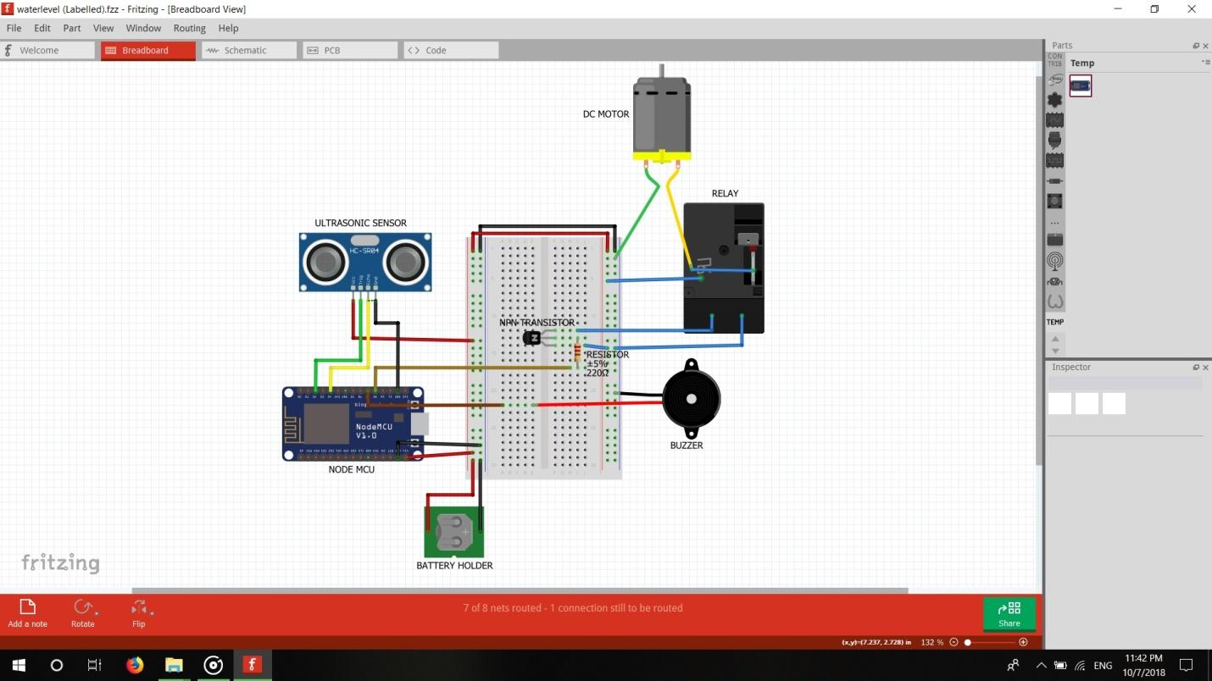

**Cad model**

**Materials required**

* 5 mm MDF sheet
* Brass nuts
* 3 mm nuts and bolts
* Fevicol and Feviqwik
* Glue gun
* Water tank
* Water pipe

**Method**

* Cut six pieces of 150mm*150mm of MDF sheet.
* Cut two pieces of 150mm*40mm each of MDF sheet and acrylic sheet.
* Using L-angle, Fevicol, Feviqwik and glue gun, make two top open boxes as shown in figure.
* Connect water pipe to water tank and secure it using glue gun.
* Connect circuit to box and secure it.

**Future scope**

Our project comprises of an ultrasonic sensor for detecting the water level. It will check the water level at regular intervals. As soon as the water level is below a particular level (as per user requirement), the device will turn on the water pump through a series of mechanisms to maintain the level. It will also turn off the water pump if the water level reaches the maximum level to avoid any overflow from the tank.